- Bluebook Page141 May 2019 variant four examination:

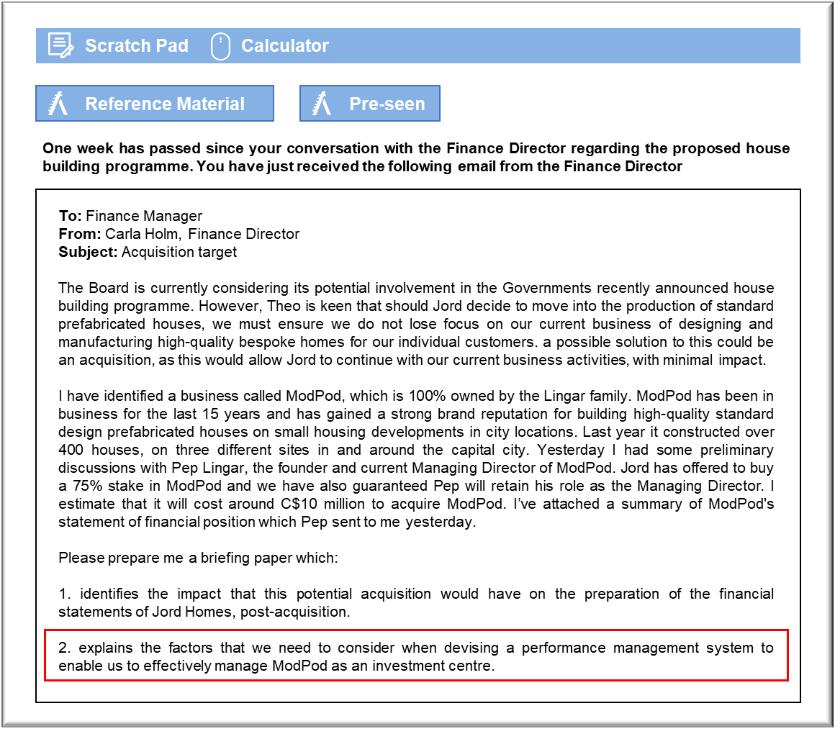

MANAGEMENT CASE STUDY MAY 2019 EXAM ANSWERS

Variant4 Task2
These answers have been provided by CIMA for information purposes only. The answers created are indicative of a response that could be given by a good candidate. They are not to be considered exhaustive, and other appropriate relevant responses would receive credit.

CIMA will not accept challenges to these answers on the basis of academic judgement.

Impact of ModPod acquisition on preparation of financial statements post
acquisition
According to international accounting standards, when a company has control over
another, a parent/subsidiary relationship is deemed to have been made. This will be
true if Jord’s offer of a 75% stake in ModPod is accepted. This means that Jord will
need to prepare group accounts on the acquisition basis and consolidate ModPod as a
subsidiary in Jord’s group financial statements. The assets of both Jord (the parent)
and ModPod (the subsidiary) will appear on the statement of financial interest, with
the 25% not owned by Jord (the non-controlling interest) appearing within equities.
Firstly, we need to consider the impact on our equity in the statement of financial
position. As a result of a 75% acquisition of ModPod, Jord’s equity will be increased by
the fair value of the equity that has been issued, which will be the purchase price
quoted of C$10 million. One other option we could propose to acquire ModPod, is that
we could acquire a 75% stake of ModPod’s shares by issuing Jord shares to the value of
the final agreed price to the Lingar family, and they would then give us 75% of their
family owned shares in ModPod in return. If we decided to use this method, these
newly issued shares would then need to be recorded at their nominal value. A credit to
the share premium account would need to be made for the difference between the
nominal value of the shares and the purchase price of C$10 million.
Secondly, we would need to value all of ModPod’s assets at their fair values, in order to
establish the amount of goodwill on acquisition. This should not be too problematic for
the tangible assets, such as buildings and equipment, but IFRS3 requires that certain
intangible assets such as brand names, that are not recognised in the subsidiaries
individual financial statements (as it would have been internally generated by
ModPod) may be recognised on consolidation, if they are identifiable.
Therefore, a challenge we will face in consolidation of the financial statements, is
establishing a fair value of our investment in the ModPod brand name. There is
unlikely to be an identifiable market value for the ModPod brand name, therefore, we
should include a separate valuation based on what we would have paid for it otherwise.
However, this indeed is likely to be highly challenging without a market value.
Therefore, we would need to apply the principles of IFRS 13 – Fair Value Measurement
to arrive at a fair value and if the fair value of the brand cannot be reliably estimated
then we would need to include it in goodwill (which would effectively be the balancing
figure in an initial consolidation).
We must ensure that the goodwill is revalued each year and any reduction in value
(known as an impairment), is written off to the statement of profit and loss for that
accounting period, with the revised value shown on the statement of financial position.
This re-valuation would never allow goodwill to be revalued upwards. Also, in the year
of acquisition, only the post-acquisition results should be included in the consolidated
results. For consolidation purposes, it is normally assumed that costs and revenues accrue evenly over the period, so the post-acquisition results are apportioned on a time
basis.
In the longer term, the impact on the consolidated financial statements will be to
increase equity and liabilities. Reported revenues and earnings may also increase in
the event that ModPod continues to undertake work outside of the Jord group. In the
short term, this is not likely, based on current capacity and the level of work ModPod
are likely to be required to commit to through this proposal.
Managing ModPod as an investment centre
Given the size of a potential investment in ModPod and the difference in the nature of
the operations undertaken, it is recommended that Pep should present a report on
performance of the investment centre at every board meeting, to maintain a good and
positive level of communication and understanding of objectives, requirements and
outcomes for the business. We also need to ensure that Pep remains motivated and
enthused in working for Jord and therefore by reporting regularly at board level should
ensure his continued drive and enthusiasm.
Retaining Pep Lingar as the Managing Director would certainly maintain continuity
and hopefully ensure that the acquisition is not too disruptive to the staff of ModPod.
The Lingar family seem to have created an excellent business and have proved their
skills and capabilities in developing and running a successful business in this growing
market. Therefore, it is recommended that we should be willing to allow Pep to
continue to retain a significant amount of discretion in managing the newly formed
investment centre. It may however also be advised to ask some of the Jord board
members to work alongside Pep in order to understand how ModPod operates and to
provide Pep and his senior managers advice on how Jord operates to ensure a smooth
integration process.
It will be important that we make it very clear to Pep what is expected of ModPod,
within the newly formed Jord Group so that ModPod has a clear sense of purpose, and
so that the freedom and flexibility offered to ModPod is put to the best possible use.
We also need to establish very early on the level of external work which ModPod will be
able to continue with or whether we in fact want to have ModPod working exclusively
for Jord on the design and delivery of its standard housing units.
We will also need to consider how we manage controllable and uncontrollable costs
within ModPod, making sure that we do not discourage ModPod from making
decisions in terms of investment in new technology on the basis that this may impact
on this investment centres performance. It would not be appropriate for ModPod to
aim to minimise costs which could discourage investment and thus impact on the
successful achievement of opportunities, such as the government’s proposed housing
programme. Therefore, we will need to be careful in how we manage ModPod as an
investment centre, as we do not want to discourage active and positive investment for
the sake of hitting overall organisational performance measures.
One of the key areas of contention is likely to be the area of intra group trading. Given
the nature of our set up it is likely that intra group transactions will take place. It will
be important to ensure that fair prices are agreed between ModPod and the rest of the
business, to that goal congruent behaviour is achieved. What we certainly don’t want is
for ModPod to be buying services from outside of the group in order for them to
improve its profitability.

